Chapter 1 DNA and genetics
extra worksheet 1: Karyotypes

It is possible to isolate some cells from a developing foetus and photograph the chromosomes in the cells. Scientists use the photograph to create a karyotype and from this they can identify genetic abnormalities.
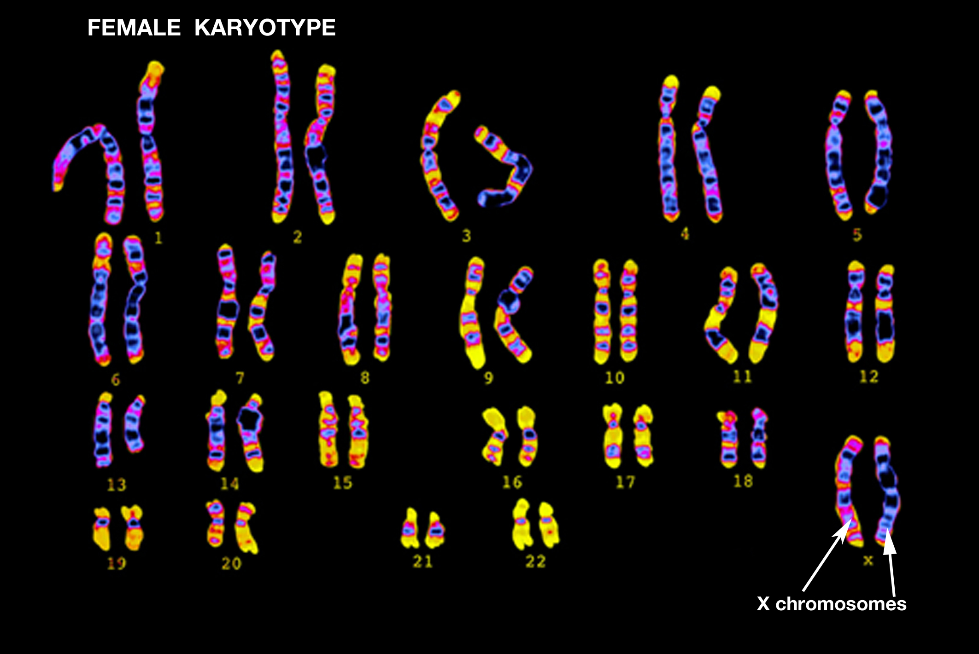
To create a karyotype, the photograph is cut up and individual chromosomes are arranged into homologous pairs according to their size, as shown in Figure 1. Homologous pairs are chromosomes with the same genes for particular characteristics at the same location along the length of each chromosome. The pairs are numbered for ease of identification. The karyotype that is produced can provide information about the developing foetus.

Figure 1
These karyotypes are of a normal male and a normal female. Look for the difference in the sex chromosomes. The Y chromosome is much smaller than the X chromosome.

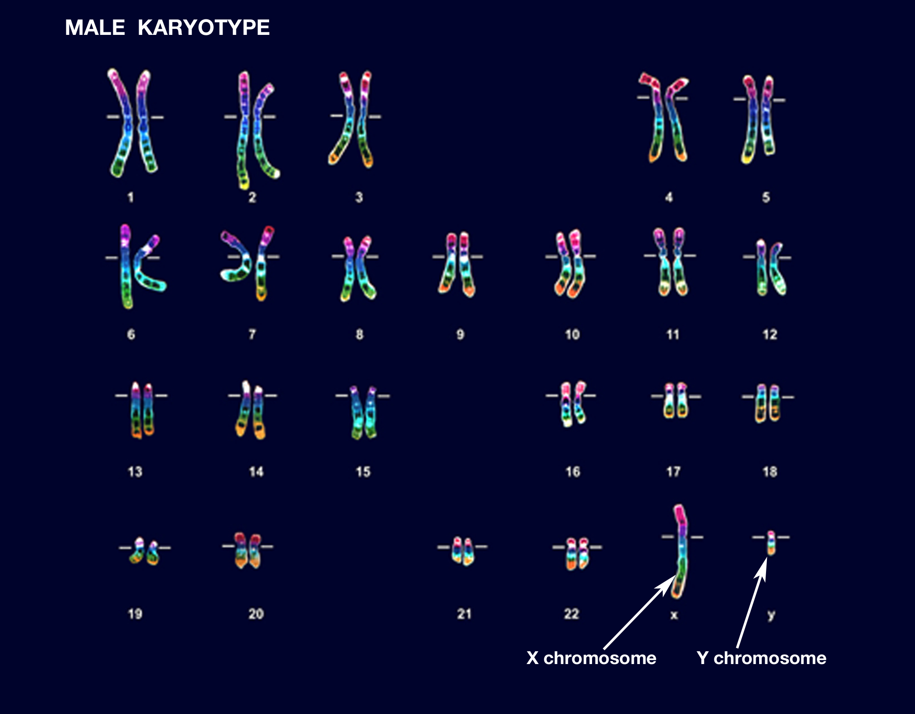

Scientists would cut up a photograph like the one in Figure 2 to create a karyotype.
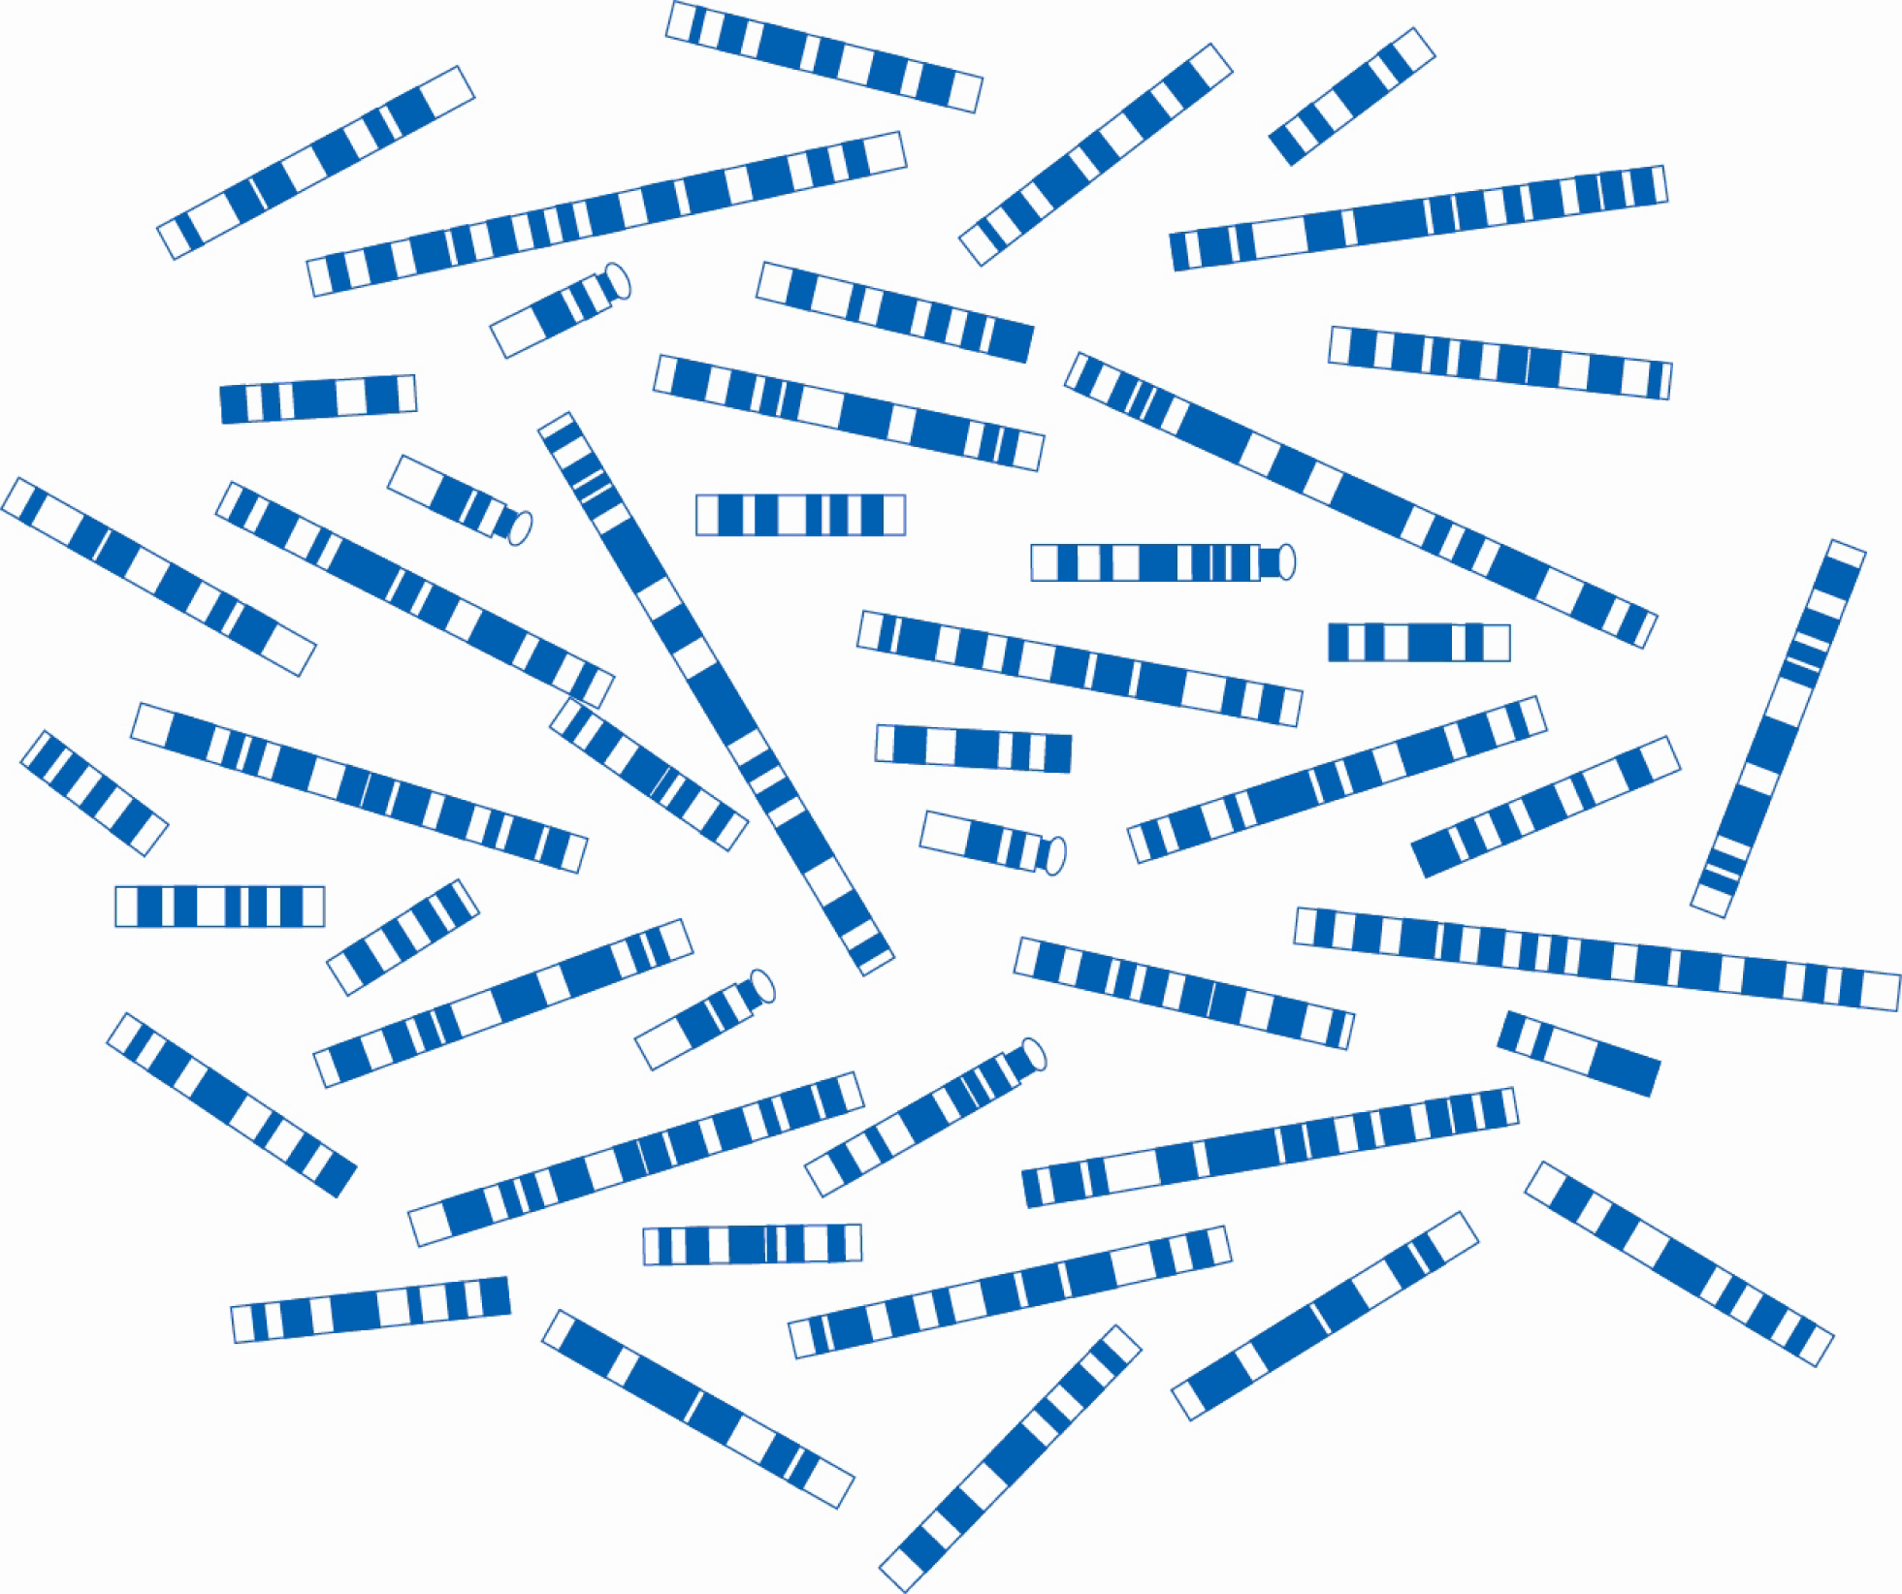
Figure 2

Questions
1 Look for homologous pairs of chromosomes in Figure 2. Colour or circle the chromosomes in each pair and give the pair a number.
a State the number of homologous pairs of chromosomes in Figure 2.

b Deduce whether this set of chromosomes came from a male or a female.

c Justify your response.

2 Identify the karyotype that matches the description of the following three syndromes.
Karyotype |  | Description of Syndrome
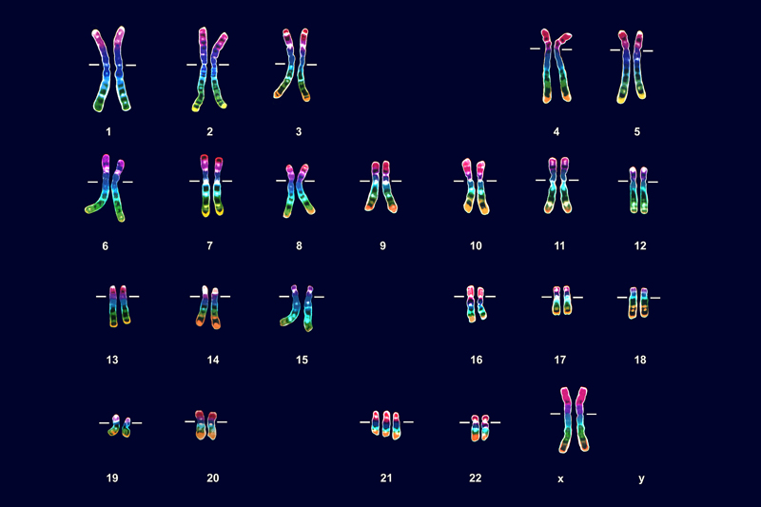 |  | Klinefelter’s syndrome:  Male with an extra X chromosome (genotype XXY).
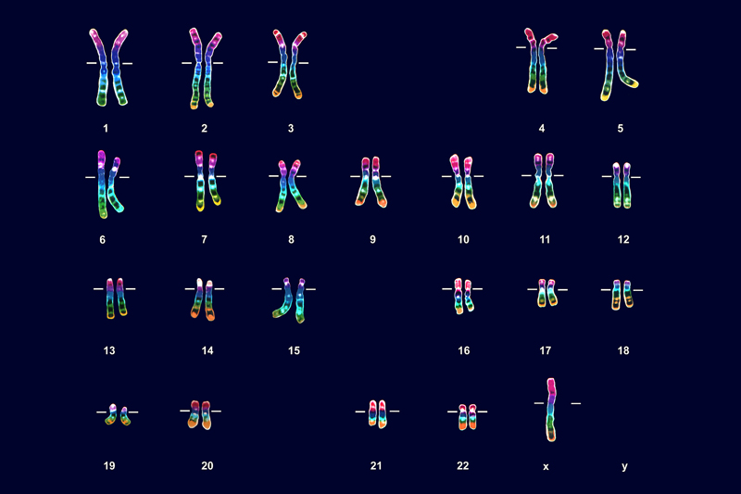 |  | Down syndrome:  Extra copy of chromosome 21.
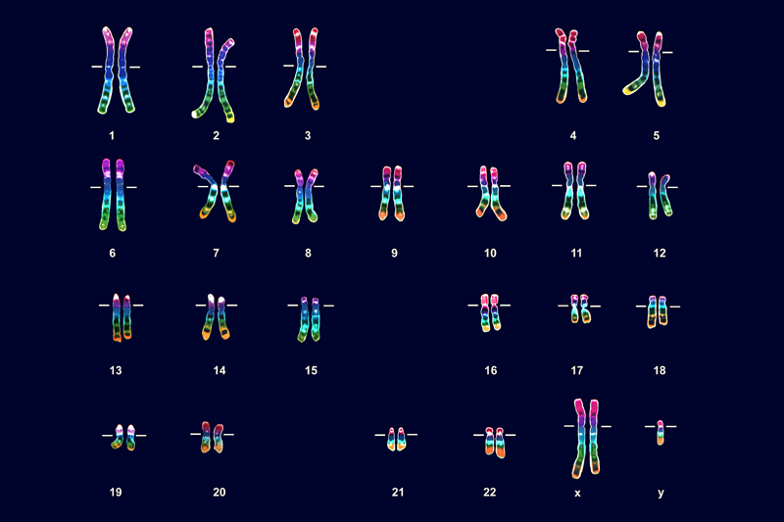 |  | Turner’s syndrome:  Absence of a Y or second X chromosome (genotype XO).

